**Website**

“We had a company build and maintain a website for and frat brought us more clients but not enough to cover their monthly cost. We had to stop using their services and I had to create a website on my own.” Quoted form the client.

It seems they are in the middle of developing the website. We may not be familiar with the technology they use, and also, it takes time to learn and to get familiar with the existing code, functions and plugins.

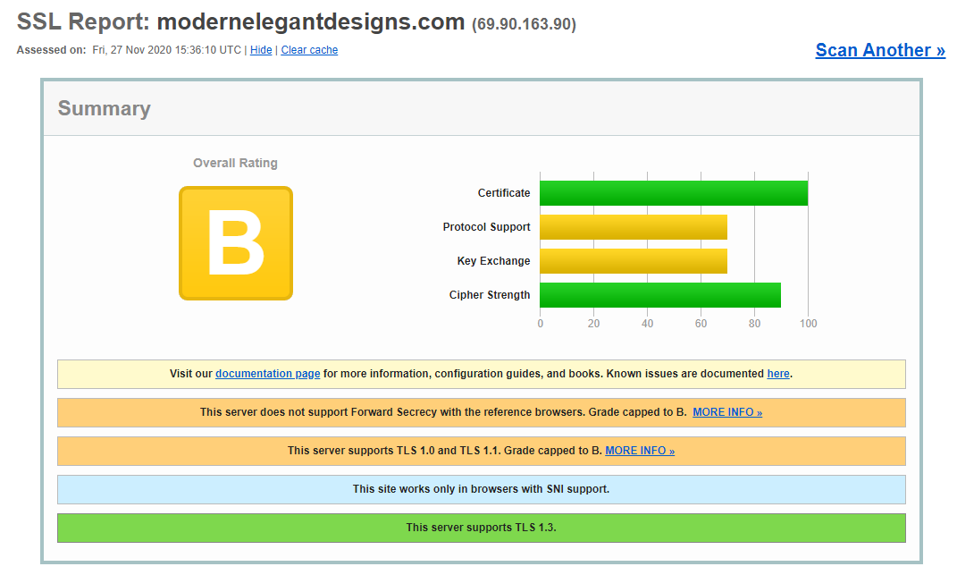

The security level of the current website is B (test from SSL LABS), and it seems to me the hosting server has certain issues. For an ecommerce website, it is better to have “A” for security level, and it is thus recommended to migrate the website to Shopify, which provides a higher level of security. Also, some functions like the Google map api, “ Gallery”, “more” button on our price, “purchase” button on the services page fail to work.

**(1)** **WEBSITE UPDATES**

-Have French/English toggle option

We can implement that using Google translate.

-Primary CTA should be “book a free quote” (or similar copy)

We may be able to fulfill this function, but it requires their further input like where to place this CTA, do they have existing UI/UX for this CTA, after triggering the CTA, what business logic do they want to have?

-Pre-consult questions on contact us (name, phone number, email, event date, location, budget w/range ($1-$2000, $2000-$3000, $3000-$5000, $5000+), # of people, theme, photo inspiration)

We may be able to fulfill this function after looking into the code and wordpress.

-Services can include (1) party-in-box (2) virtual consults @ hourly rate

Need further clarification on what they want to have.

-Basic online store for party-in-a-box

Considering we only have 2 weeks for this client, we may not be able to do this. It takes time to do the requirement analysis, wireframing, UI/UX design, e-commerce function implementation, testing and publishing. During the process, it also requires extra time to discuss and modify the design with the client. It is suggested they can hire a freelancer or reach out to the Shophere team.

-Synchronize web/mobile views

Currently, the website is responsive.

-Add “Corporate Events” page with past client logos, new copy

Considering we only have 2 weeks for this client, we may not be able to do this. It takes time to do the requirement analysis, wireframing, UI/UX design, event management function implementation, testing and publishing. During the process, it also requires extra time to discuss and modify the design with the client. It is suggested they can hire a freelancer or reach out to the Shophere team.

-Take down modernelegantdesigns.com and redirect to .ca

We can complete this if they can give us access to their access to the domain. However, if they decide to transfer to shophere, it is better to change the domain name later.

-Change email to modernelegantdesigns.ca

We can complete this if they can give us access to the hosting service provider. However, if they decide to transfer to shophere, it is better to change this later.

**Digital Marketing concern/questions:**

Hootsuite/Mailchimp?

What kind of ads do you want?

What kind of ads did you run before? (IG, FB?)

**Digital Marketing Notes:**

* Focus on: Instagram, Pinterest? → Pinterest Business Account?
* Pinterest best practices
* Alternative to Hootsuite?
* Blogging
* Social Media Strategies: used to follow a calendar ; needs to know when is the best time to post, etc.

Pinterest How-to/Best Practices

Content Management Document

Influencer Marketing

**Copywriting concerns/questions:**

Website copy edit: “contact us” form for budgeting each event  
SEO research: need!!

* Google SEO: event planning industry

Industry research - event planning best practices for digital media

**Graphic Design concerns/questions:**

Working files to share?

* Currently has a logo
* Uses canva
* Colour: purple

**Deliverables:**

1. Pinterest + blog how-to
2. CMS
3. Ads - influencer marketing/FB and IG ads
4. Brand Style Guide + poster
5. SEO research for Google searchability + keywords

Questions for Bobbie:  
Website - pop up details/ chat with us - which one do you prefer?

Would you consider influencer marketing? Would you like a best practices guide?

Transfer website to .ca on squarespace and .com is on wordpress

Working files for logo/graphic design   
Social media log-ins: only to check is business profile is set-up

